***Logistic Regression :***

---> Logistic regression is about predicting binary variables i.e when the target variable is categorical.

---> The aim of logistic regression is to predict some unknown probability P for a successful event, for any given linear combination of independent variables (features).

---> the output is natural logarithm of the odds , also known as logit. The base of the logarithm is not important but taking logarithm of odds is.

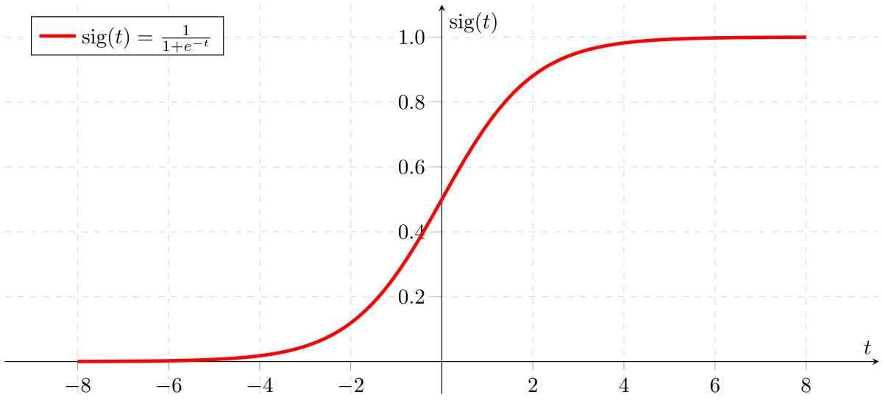

* If ‘Z’ goes to infinity, Y(predicted) will become 1
* if ‘Z’ goes to negative infinity, Y(predicted) will become 0.

odds :

-> Higher the odds, better is the chance for success. Range of odds can be any number between [0 , ∞].

Odds ratio :

-> is the ratio of odds.

-> odds ratio can vary between 0 to positive infinity, log (odds ratio) will vary between [-∞, ∞].

Specifically when odds ratio lies between [0,1], log (odds ratio) is negative.

-> Bernoulli distribution is a discrete distribution with two possible outcomes labelled by n=0 and n=1, in which n=1 (successful event) occurs with probability P and failure i.e.

n=0 occurs with a probability 1-P.

-> The dependent variable in logistic regression follows Bernoulli distribution having an unknown probability P. Therefore, the logit i.e. log of odds, links the independent variables

(Xs) to the Bernoulli distribution.

**Types of Logistic Regression :**

**1. Binary Logistic Regression**

* The categorical response has only two 2 possible outcomes. Example: Spam or Not

**2. Multinomial Logistic Regression**

* Three or more categories without ordering. Example: Predicting which food is preferred more (Veg, Non-Veg, Vegan)

3. **Ordinal Logistic Regression**

* Three or more categories with ordering. Example: Movie rating from 1 to 5

**Decision Boundary**

To predict which class a data belongs, a threshold can be set. Based upon this threshold, the obtained estimated probability is classified into classes.

Say, if predicted_value ≥ 0.5, then classify email as spam else as not spam.

Decision boundary can be linear or non-linear. Polynomial order can be increased to get complex decision boundary.

**Cost Function :**

Why cost function which has been used for linear can not be used for logistic?

* Linear regression uses mean squared error as its cost function. If this is used for logistic regression, then it will be a non-convex function of parameters (theta).
* Gradient descent will converge into global minimum only if the function is convex.’

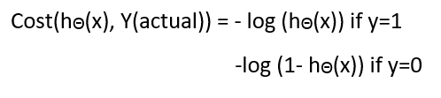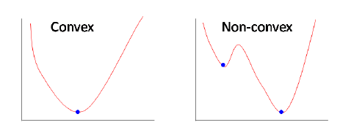

**Loss** **Function** :

* Logg loss is the loss function for logistic regression.

<https://towardsdatascience.com/logistic-regression-detailed-overview-46c4da4303bc>